**PRACTICAL NO 9:**

**Aim: Design application using Struts2. Application must accept user name and greet user when command button is pressed.**

**Step 1: Download struts2-suite-1.3.5 zip file -->Extraxt it in a folder --> Open netbeans 8.2 --> Click ontools --> Click on pulgins --> Go to downloaded --> Click on add plugins --> Access that folder whereyou have extracted the file --> You will get 3 files with extestion .nbm in that folder import them andclick on install.**

**Step 2: Create java a web application --> Click on file --> New Project --> Java Web --> Web Application**

**-->Give name of the project --> Select Server -->Select Struts2 --> Click on finish.**

**Step 3: Create 1 package and inside that add 1 java class file --> create getters and setter in it.**

**Hello_action.java**

package action_jsp;

import com.opensymphony.xwork2.ActionSupport;

// everything in here must be kept public to have package level access. public class hello_action extends ActionSupport

{

private String name;

// getter and setter methods for the form element value

public String getName()

{

return name;

}

public void setName(String name)

{

this.name = name;

}

//method that returns success or failure on action public String execute()

{

return "success";

}

}

### Step 4: Create 1 folder in Web Pages folder and inside that and add 2 jsp file.

**index.jsp**

<%@page contentType = "text/html" pageEncoding = "UTF-8"%>

<%@taglib prefix = "s" uri = "/struts-tags" %>

<html>

<body>

<s:form method = "post" action = "hello_action">

<s:label name = "label1"/>

<s:textfield value="Enter your name" name = "name"/>

<s:submit value = "CLICK" name = "submit" align="left"/>

</s:form>

</body>

</html>

### result.jsp

<%@page contentType = "text/html" pageEncoding = "UTF-8"%>

<%@taglib prefix = "s" uri = "/struts-tags" %>

<html>

<body>

<h1>Hello <s:property value = "name"/></h1>

</body>

</html>

### Step 5: Check you web.xml and struts.xml both files will be in configuration file.

**Struts.xml**

<!DOCTYPE struts PUBLIC

"-//Apache Software Foundation//DTD Struts Configuration 2.0//EN" ["http:](http://struts.apache.org/dtds/struts-2.0.dtd)/[/struts.apache.org/dtds/struts-2.0.dtd"](http://struts.apache.org/dtds/struts-2.0.dtd)>

<struts>

<include file="example.xml"/>

<!-- Configuration for the default package. -->

<package name="default" extends="struts-default">

<action name = "hello_action" class = "action_jsp.hello_action" method = "execute">

<result name = "success">result.jsp</result>

<result name = "failure">index.jsp</result>

</action>

</package>

</struts>

### Web.xml

<?xml version="1.0" encoding="UTF-8"?>

<web-app version="3.1" xmlns=["http://xmlns.jcp.org/xml/ns/javaee](http://xmlns.jcp.org/xml/ns/javaee)" xmlns:xsi="[http://www.w3.org/2001/XMLSchema-instance"](http://www.w3.org/2001/XMLSchema-instance)xsi:schemaLocation="<http://xmlns.jcp.org/xml/ns/javaee><http://xmlns.jcp.org/xml/ns/javaee/web-> app_3_1.xsd">

<filter>

<filter-name>struts2</filter-name>

<filter-class>org.apache.struts2.dispatcher.FilterDispatcher</filter-class>

</filter>

<filter-mapping>

<filter-name>struts2</filter-name>

<url-pattern>/*</url-pattern>

</filter-mapping>

<session-config>

<session-timeout> 30

</session-timeout>

</session-config>

<welcome-file-list>

<welcome-file>jsp/index.jsp</welcome-file>

</welcome-file-list>

</web-app>

### Output:

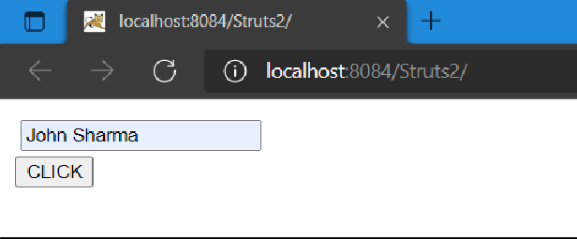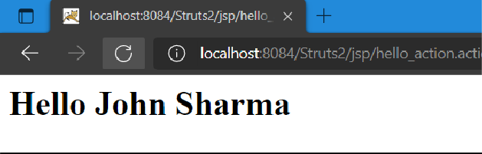

**Conclusion: Successfully designed application using Struts2.**